**System Requirements Specification**

Library Management System

#### Document Version 1.0 Prepared by MATTA KIMANI

#### November 21, 2022

# TABLE OF CONENTS

TABLE OF CONENTS I

Revision History & Intermediate Sign-offs 1

1. Sign-offs [version 1.0] 1
2. Introduction 1
   1. Purpose of the Document 1
   2. Document Conventions 1
   3. Glossary 2
   4. Intended Audience 3
   5. Project Information 3
   6. Information for Readers 3
3. Overall Description 3
   1. Product Perspective 3
   2. Features 4
   3. User Classes and Characteristics 5
   4. Operating Environment 5
   5. Constraints 5
   6. User Documentation 5
   7. Assumptions and Dependencies 6
4. Feature Details 6
   1. Web Based & Accessible from Devices of All Sizes [FE01] 7
      1. Details 7
      2. User Actions and System Responses 7
      3. Use cases 7
   2. Accessible Only to Authenticated and Authorized Users [FE02] 7
      1. Details 7
   3. Librarian Data Management [FE03] 7
      1. Details 7
      2. User Actions and System Responses 7
      3. Use Cases 8
   4. Report Generation [FE04] 8
      1. Details 8
      2. User Actions and System Responses 8
      3. Use Cases 8
   5. Auditing and Logging User Activities [FE05] 9
      1. Details 9
      2. User Actions and System Responses 9
      3. Use Cases 9
5. Data 9
   1. Storage Requirements 9
   2. Data Retention Policies 9
   3. Data Backup 10
   4. Data Security 10
   5. Data Transfer Requirements 10
6. External Interface Requirements 10
   1. User Interface Requirements 10
   2. Hardware Interfaces 10
   3. Software Interfaces 11
   4. Communications Requirements 11
   5. Licensing Requirements 11
7. Other Non-functional Requirements 11
   1. Performance Requirements 11
   2. Security Requirements 11
   3. Safety Requirements 11
   4. Quality Attributes 11
      1. Applicable Standards 11
      2. Structural Robustness 11
      3. Usability 11
   5. Availability 11
8. Testing Related Information 12
9. Deployment Information 12
   1. Hosting requirements 12
   2. SSL requirements 12

Appendix A: Use Case Diagram 13

Appendix B: Activity Diagram – Student 14

Appendix C: Activity Diagram – Librarian 15

**Revision History & Intermediate Sign-offs**

|  |  |  |  |  |
| --- | --- | --- | --- | --- |
| **Author** | **Date** | **Reasons for changes** | **Version** | **Signatory [Name, Designation and Signature with date]** |
| MATTA KIMANI | November 20,  2022 | First Draft | 0.1 |  |

1. **Sign-offs [version 1.0]**

I acknowledge that all the information provided here in this document are accurate and correctly represent the library management application we are trying to build for the university. I also acknowledge that any requirements not discussed in this document are beyond the scope of the project being undertaken and may incur additional charges/time/resources if those new requirements/features become necessary to implement.

|  |  |  |  |  |  |
| --- | --- | --- | --- | --- | --- |
| **#** | **Name** | **Designation** | **Company** | **Signature with date** | **Document Version** |
| **1** |  |  |  |  | **1.0** |
| **2** |  |  |  |  |
| **3** |  |  |  |  |
| **4** |  |  |  |  |
| **5** |  |  |  |  |

1. **Introduction**

## Purpose of the Document

This SRS document provides details of both functional and non-functional requirements for the **Library Management System** 1.0 (**LMS**1.0). This document intended to create a clear understanding among all stakeholders (both from client side and the service provider) regarding the system. It will also build a common platform for communication among the stakeholders.

LMS will be a web application/portal that will allow the librarians to manage the university library using a computerized system. Students will be able to borrow books and check their deadlines; see which books their friends have read and which books are trending. The portal will be using English for communication.

## Document Conventions

The following conventions are used throughout the document -

* + 1. All technical terms are italicized.
    2. All abbreviations are written with bold-faced type.
    3. All figure descriptions are italicized.
    4. The terms System, portal and application are all used interchangeably throughout the document.

## Glossary

List of terms and abbreviations:

|  |  |
| --- | --- |
| **Term/Abbreviations** | **Definition/Full form** |
| Librarian | Any person who manages the books. |
| User | Anyone who will be given permission to access the system to carry out tasks |
| Database | Collection of all the information monitored by this system. |
| System | The web portal/application being developed |
| Intranet | A network connecting only devices (computers) within an organization, not visible to the outside world. |
| Stakeholder | Any person with an interest in the project who is not a developer. |
| Browser | A software that is used to view web pages and collect web pages from distant servers. |
| Availability | Availability of any system to the users for doing their tasks. |
| Scalability | Ability of a system to support the growing number of users. |

|  |  |
| --- | --- |
| DBMS | Database Management System - The software used to manage (store, update, delete, search) data. |
| RDBMS | Relational Database Management System - The software used to manage (store, update, delete, search) data in a structured way and in separate tables with columns representing attributes of an object and each representing specific object. Tables are usually linked together to form a complete set of data. |
| SRS | Software Requirement Specification - a document specifying different aspects and functionalities of a software system |
| SSL | Secure Socket Layer - Technology specifications (protocol) that defines how secure connection can be established between communicating computers using a network, especially the internet. |
| ER | Entity relation - a relational database term that denote the relations among objects/entities |

## Intended Audience

The intended users of this document are all stakeholders of the project. The implementing team will use this document to drive the development process. The client will use this document to verify if the concerned system is built according to their need.

## Project Information

**LMS1.0** will be a web application/portal to allow the **UNIVERSITY Of CODE** librarians keep records regarding books and students (borrowers). It will be a *responsive* web application so that it is usable from devices of all sizes - desktops, mobiles, tabs, and laptops.

The application will have easy to use and intuitive user interfaces so that anyone can without any difficulties. Students will be able to search and view any book information, keep track of their borrowed books, and get notified the returning deadlines with minimum efforts.

## Information for Readers

The rest of the document describes the product (**LMS**) in concern.

* Section 3 and 4 details out the product’s features and associated use cases.
* Section 5 describes the data that the product has to deal with.
* Section 6 deals with the external requirements of the system.
* Section 7 describes the other non-functional requirements of the system.
* In section 8, testing plan is discussed.
* In section 9, deployment related information is briefly discussed.

1. **Overall Description**

## Product Perspective

**LMS1.0** is a new web-based system that will be set to record keeping ;regarding books and students (borrowers), manually checking books, keeping records on issued books, etc. The system will be hosted at server specified and maintained by the client. Figure 1 is a pictorial representation of the system (context diagram) that shows the system from a bird’s eye view. It shows its interactions with external entities. Different types of users will use the system. There detail descriptions will be discussed in the “User Classes and Characteristics” section.

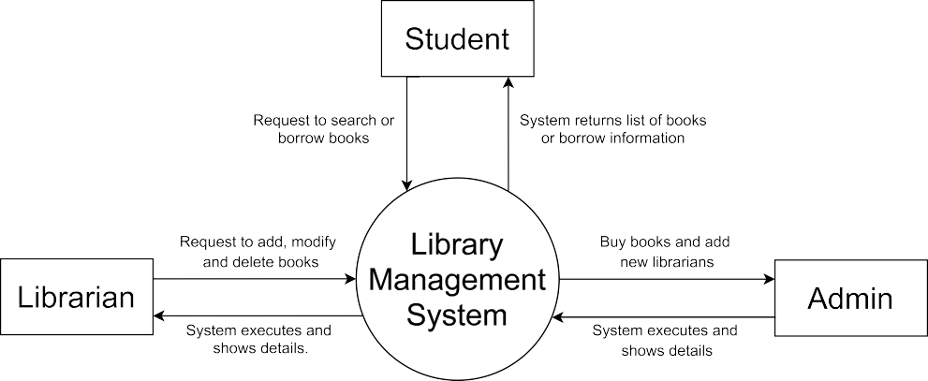

***Figure 1*** *Context Diagram for LMS 1.0*

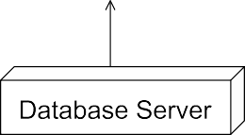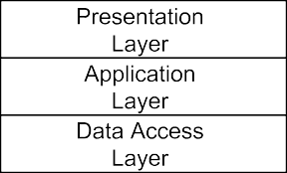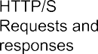

***Figure 2*** *Deployment and internal architecture*

The system will be deployed in a web server and will use a database server for data storage. Internally, the system will be composed of three layers - the presentation layer which will be responsible for displaying/collecting information and records from users, the application layer will implement the book search and book recommend logic and the data access layer will be responsible for dealing with the relational data store.

## Features

Features are listed below. **High**, **Medium,** and **Low** are used to indicate the importance of each feature.

|  |  |  |  |
| --- | --- | --- | --- |
| **Feature ID** | **Description** | **Priority** | **Requester** |
| **FE01** | Web based and accessible from devices (with internet connection) such as desktop, laptop, mobile and tablet PCs. | High |  |
| **FE02** | Accessible only to authenticated and authorized users | High |  |
| **FE03** | Student data management for example: personal details, book read history, borrow history and so on. It will also allow registered student search and viewing student list. | High |  |
| **FE04** | Report generation based on user needs. | Medium |  |
| **FE05** | User management and auditing user activities | High |  |

## User Classes and Characteristics

Following user classes are identified but the list is subject to change

|  |  |
| --- | --- |
| **User Class** | **Characteristics** |
| Student | This class users can search and borrow books, view and modify their own details, and view their borrow history. |
| Librarian | Users of this class will be solely responsible for entering/updating student data and add/modify books. They can do entry/updates only after a higher authority authorizes them to do so. |
| Admin | Someone, probably from the management/IT department who can view records of all students, can authorize data entry or updates. |
| Director | The supervising manager who can view all records of all students, can view user activity logs, can authorize data entry or updates, can generate various reports. |

## Operating Environment

|  |  |
| --- | --- |
| **ID** | **Description** |
| OE01 | System will be web based and accessible from all types of browsers from any location and preferably at any time. |
| OE02 | All data (student, user data and so forth) must be kept in a secure relational database management system. |
| OE03 | System must be available preferably at all times. |

## Constraints

|  |  |
| --- | --- |
| **ID** | **Details** |
| CO01 | MySQL ***RDBMS*** for data storage |
| CO02 | ***JAVA*** for backend and ***ReactJS-bootstrap*** for frontend |
| CO03 | Data Encryption (***SSL***) must be used |
| CO04 | System response to user queries must be within 5 seconds of the initiation of the request, provided network and server |

## User Documentation

Documentation for users will be inline, available on each page of the system.

## Assumptions and Dependencies

|  |  |
| --- | --- |
| **ID** | **Details** |
| DEP01 | Client interface will depend on ***ReactJS*** |
| DEP02 | ***PDF*** will be used for ***PDF*** generation. |
| AS01 | Client browsers will be *JavaScript* enabled. |
| AS02 | Both application server and database servers will be hosted in a secure and protected environment to encounter intruders and natural disasters. |
| AS03 | Database hosting services will provide data backup facility. |

1. **Feature Details**

The system will have mainly three components/modules - user management module, report module and student management module. Figure 3 shows the components of the system. The features of each module are discussed in detail in the subsequent sections.

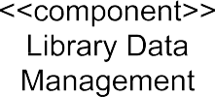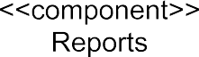

***Figure 3*** *Component diagram for LMS 1.0*

## Web Based & Accessible from Devices of All Sizes [FE01]

### Details

The system will be a *responsive* web portal, which will be accessible from devices (with internet connection) of all sizes such as desktop, laptop, mobile and tablet PCs.

### User Actions and System Responses

Not applicable

### Use cases

Not applicable.

## Accessible Only to Authenticated and Authorized Users [FE02]

### 4.2.1 Details

The system will use role-based access to valid users of the system. Login will be used to provide access and then user class/ role will be used to allow access to specific resources on the portal.

## Librarian Data Management [FE03]

### Details

The system will allow authorized users to perform librarian personal data management tasks such as adding a new book, modifying any book details, and modify borrow details of any user.

### User Actions and System Responses

|  |  |
| --- | --- |
| **User Action** | **System Response** |
| Authorized Librarian requests to add a new book. | The system responds with book details entry form to collect data. |
| Authorized Librarian requests to edit a book detail. | The system looks up selected book and presents it to the user for edition in a form. |
| Authorized Librarian asks for a list of all registered students. | The system looks up all students from database and shows a paged students list. |
| Authorized Student wants to search for a book | The system shows a search form that allows user to search for a book. |
| Authorized Student wants to borrow for a book | The system shows a form that allows user to enter the book details to borrow. |

### Use Cases

|  |  |  |
| --- | --- | --- |
| **ID** | **Use Case** | **Details** |
| FE03_UC01 | Add new student | The system opens up to add new student with options to save all sorts of records – student id, email, phone number and so on. It then validates and saves entered record and notifies user of success/failure |
| FE03_UC02 | View student list | The system shows a list of students in paged format with configurable number of records per page. |
| FE03_UC03 | Edit student record | The system retrieves record from database of intended student and presents it in a form for user to update. It then validates and saves entered record and notifies user of success/failure |
| FE03_UC04 | Edit book record | The system retrieves record from database of intended book and presents it in a form for user to update. It then validates and saves entered record and notifies user of success/failure |
| FE03_UC05 | Book search | The system shall provide a search form to search for book based on name or categories. It will present a list of books if record matching the criteria are found in the database. |
| FE03_UC06 | Book record viewing | The system retrieves record of the intended book and shows and uneditable detailed view of the record. |

## Report Generation [FE04]

### Details

The system will allow authorized users to generate reports of various types.

### User Actions and System Responses

|  |  |
| --- | --- |
| **User Action** | **System Response** |
| Authorized User wants to generate report. | The system responds with a report form to specify criteria for report generation. It then generates a report with retrieves data. |
| Authorized user wants to print report | The system responds with a report form to specify criteria for report generation. It then generates a report allowing user to print. |

### Use Cases

|  |  |  |
| --- | --- | --- |
| **ID** | **Use Case** | **Details** |
| FE04_UC01 | Generate report | The system displays a report form to specify criteria for report generation. It then generates a report with retrieves data and presents it to the user. |
| FE04_UC02 | Print report | The system displays a report form to specify criteria for report generation. It then generates a report with retrieves data that has option for printing. When the user selects printing option, a pdf is generated and downloaded to user’s device. |

## Auditing and Logging User Activities [FE05]

### Details

The system will allow authorized user with appropriate level of clearance to manage other users, such as allowing/ disallowing access, monitoring user activities for security and maintaining confidentiality.

### User Actions and System Responses

|  |  |
| --- | --- |
| **User Action** | **System Response** |
| Authorized user wants to add a new book | The system responds with a user creation form |
| Authorized user wants to search for a book | The system presents a list of books matched with the search criteria. |
| Authorized user wants to borrow a book | The system presents information about borrowing the book. |
| Authorized user wants to monitor user activities | The system generates a report of user activities of the selected user. |

### Use Cases

|  |  |  |
| --- | --- | --- |
| **ID** | **Use Case** | **Details** |
| FE05_UC01 | Add Book | The system displays form to enter the book detail. It then saves the book and notifies user of success/failure. |
| FE05_UC02 | List Student | The system shows a list of registered students. |
| FE05_UC03 | Deactivate user | From user list, the user selects the user to deactivate. The system deactivates the user and notifies results. |
| FE05_UC04 | Activity report | The system shows the activities of the selected user retrieving them from the system log. The list will be sortable by date/activities and will be filterable. |

1. **Data**

## Storage Requirements

* MySQL database server will be used for data storage and retrieval.
* Considering the worst-case scenario, each student record may take 7KB of data. Initially 500MB disk space may be required for 1000 student. It will increase based on the number of students.
* The above disk space requirement does not include the database system software space requirements or space requirements of Operating System or other needed software to run the server smoothly.
* Archival data should be stored on machines other than the production machine.

## Data Retention Policies

Data retention period will be decided based on government requirements.

## Data Backup

* Data backup must provide at the database host level.
* Application-level data backup may be provided if required by the client at additional cost.

## Data Security

* Data must be secured so that hackers cannot access them
* Data must be user id and password protected (database user credential required to access besides the application-level user access protocol)
* Application’s communication with data store must be secured, preferably over an intranet/private connection
* All user passwords must be kept in the database in encrypted format.
* SQL Injection attack must be in consideration when accepting user input to be used in database access.

## Data Transfer Requirements

1. **External Interface Requirements**

This section defines the system’s interfaces with hardware, software, data storage entities (***RDBMS***) and so on.

## User Interface Requirements

User interfaces have to be intuitive requiring very little training for users. The following are some of the requirements -

* Each page must have a **Help** button that will invoke inline help system to show help page for the current screen.
* Once logged in, all pages must at all times show all the menu items available for the current user.
* Color scheme must not strain the eyes of the users.
* All buttons must be big enough for users to easily click on them.
* All links must be easily visible and follow link-specific standards such as underlined text.
* All screens must be responsive to be usable from devices of all sizes.
* Non-standard HTML tags must not be used.
* Each screen should have appropriate titles.
* The pages must be supported by all major browsers
* User interface will use internationalization to support Bangla and English both.
* W3C guidelines for accessibility will be followed as much as possible.

## Hardware Interfaces

The system is a web application requiring internet connection. So, all hardware related to internet connectivity are included under this category. It will be hosted in server. So, server hardware is also in the list of hardware interfaces for the system.

## Software Interfaces

Not applicable at this time.

## Communications Requirements

The system is a web application. It will need the internet/intranet to communicate. It will use HTTP/S protocol for communication with clients (browsers).

## Licensing Requirements

Not Applicable

1. **Other Non-functional Requirements**

## Performance Requirements

* The system has to provide responses within an acceptable amount of time, 5 seconds to be exact.
* As the number of users grows, the system must be able to scale to handle increasing load.
* As the data grows, the system must be able to handle quick entries, updates, or searches for data store.

## Security Requirements

* SSL for data security and safety
* Passwords must be kept encrypted inside user table.
* Application Server and Database server must be in a secure environment.
* Users must be forced to change passwords every 6 months.
* Strong passwords must be enforced by the system.

## Safety Requirements

* Application Server and Database server must be in a safe environment to guard them against any physical damage either caused by human factors or natural disasters**.**
* Standards for developing web applications.

## Quality Attributes

### Applicable Standards

The system will be built based on current and feasible standards for building web application.

### Structural Robustness

* + - * The system must be developed using MVC architecture for future maintenance.
      * Relations must be normalized to an acceptable level.

### Usability

Usability of the software will be determined from conversation and interviews with user base. Furthermore, testing will be done to ensure fulfillment of usability criteria.

## Availability

System must have 99% uptime. Any downtime should be due maintenance or emergency situation arising from natural or man-made disasters.

1. **Testing Related Information**

* The software must be tested at all levels of development.
* Unit testing will be used through JUnit
* Pages will be tested using Selenium IDE for broken links, data validation logic and so on.
* JMeter will be used for load testing and stress testing.
* Integration testing will be performed as needed.
* UI testing will be one ensure usability of each page

1. **Deployment Information**

## Hosting requirements

The system should be hosted in a server that will be capable of handling simultaneous connections from clients. It should be able to handle increasing number of users.

## SSL requirements

SSL certificate must be installed for the domain that application can be reached at. It will ensure data security through encryption.

**Appendix A: Use Case Diagram**

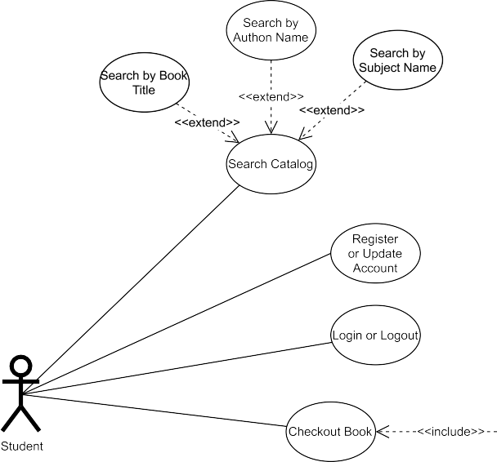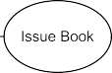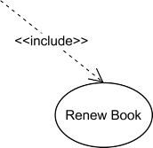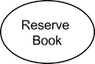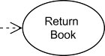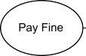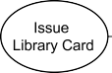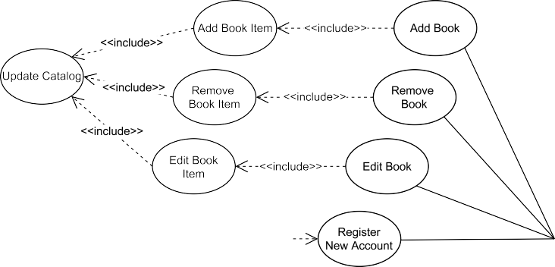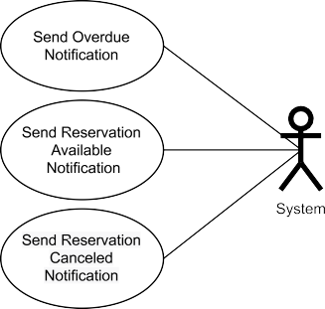

***Figure*** *Use Case Diagram*

**Appendix B: Activity Diagram – Student**

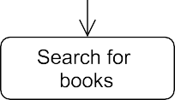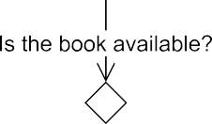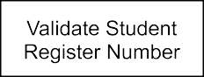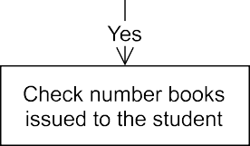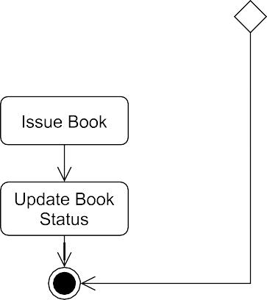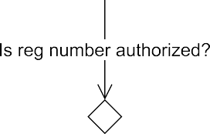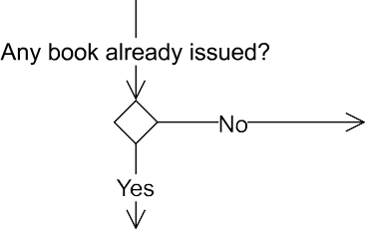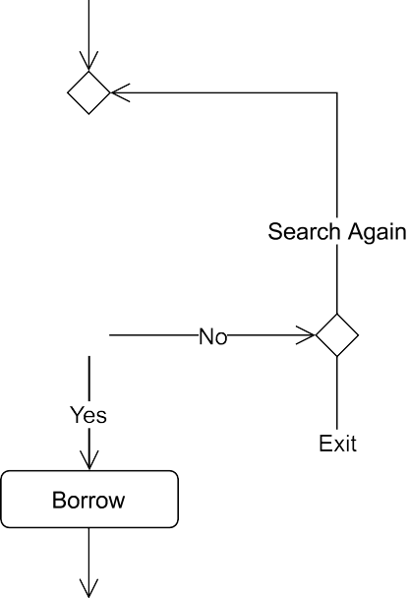

***Figure*** *Student Activity Diagram*

**Appendix C: Activity Diagram – Librarian**

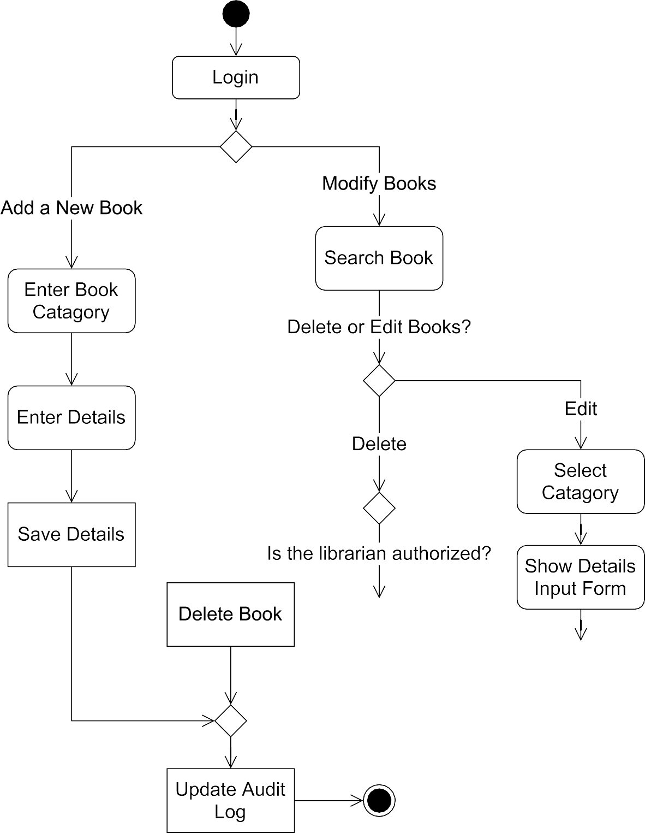

***Figure*** *Librarian Activity Diagram*